Courier Management System (CMS)

User Story:
Courier and logistics companies often struggle to efficiently manage shipments and deliveries due to reliance on manual processes and disconnected systems. The absence of a centralized shipment tracking mechanism makes it difficult to monitor parcel movement in real time, resulting in delayed delivery updates and poor visibility for customers. Delivery agent assignments are performed manually, increasing the chances of scheduling conflicts and operational delays. Furthermore, the lack of automated notifications prevents timely communication with customers, while the absence of performance analytics limits managerial insight into operational efficiency. Managing multiple branches becomes complex without an integrated platform, leading to coordination issues across locations. Collectively, these challenges result in customer dissatisfaction, reduced productivity, operational inefficiencies, and ultimately revenue loss for the organization.

1. INTRODUCTION

1.1 Project Overview :

Courier and logistics companies face challenges in efficiently managing shipments and deliveries due to manual operations and disconnected systems. These issues lead to delayed updates, poor customer visibility, and operational inefficiencies.
The Courier Management System (CMS) is a Salesforce-based cloud solution that centralizes shipment booking, tracking, delivery agent assignment, automated status updates, billing, and analytics. The system improves operational efficiency, enhances customer satisfaction, and provides real-time business insights.

1.2 Purpose :

The purpose of the Courier Management System (CMS) is to automate and centralize courier and logistics operations using the Salesforce platform. The system aims to replace manual and fragmented processes with an integrated digital solution that enables efficient shipment booking, real-time tracking, delivery agent assignment, automated notifications, billing, and performance reporting. By providing a single, unified platform for managing shipments across multiple branches, CMS improves operational visibility, enhances customer communication, reduces delays and errors, and supports faster decision-making through analytics. Ultimately, the system is designed to increase service efficiency, customer satisfaction, and overall business profitability.

2. IDEATION PHASE
2.1 Problem Statement (Customer Problem Statement Template)

PS | I am (Customer) | I’m trying to | But | Because | Which makes me feel
PS-1 | Branch Manager | manage shipments efficiently | tracking is manual | systems are disconnected | stressed
PS-2 | Customer | track parcels | updates are delayed | no centralized system | uncertain

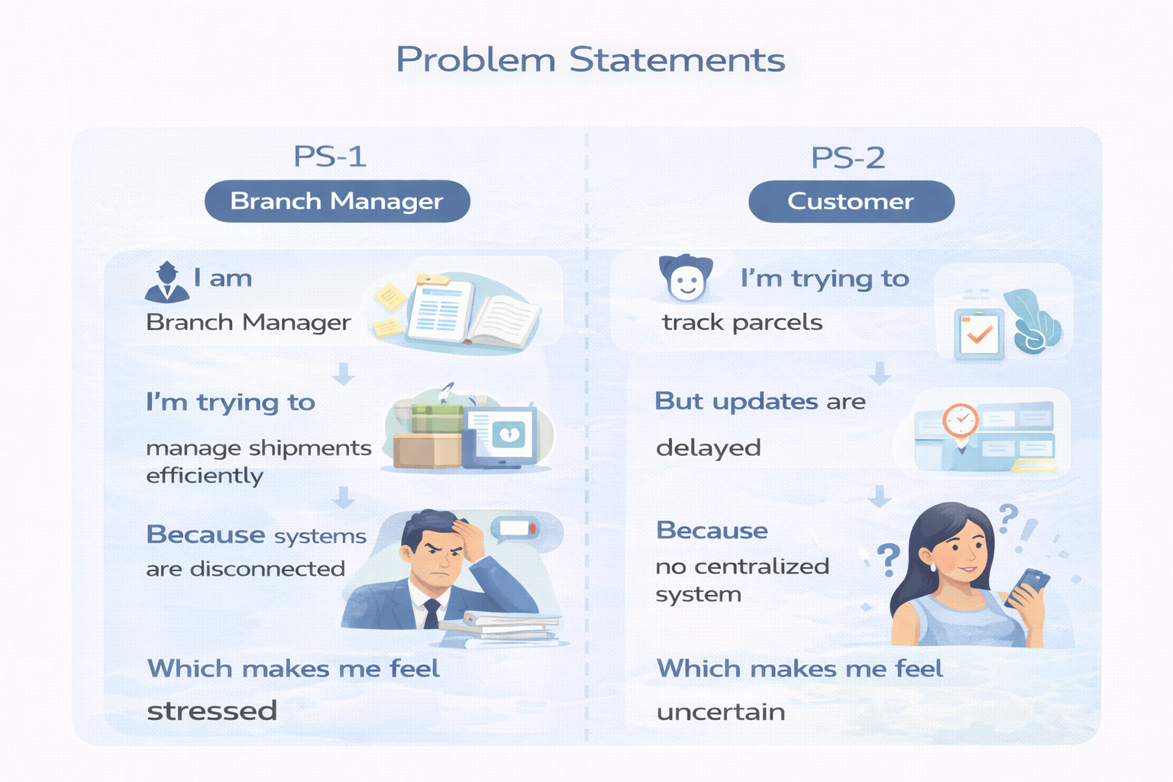

2.2 Empathy Map Canvas
User Persona: Branch Manager

Think & Feel: Concerned about delays & errors

Hear: Customer complaints

See: Registers & spreadsheets

Say & Do: Manual follow-ups

Pain: Delivery conflicts & missed updates

Gain: Automated tracking & dashboards

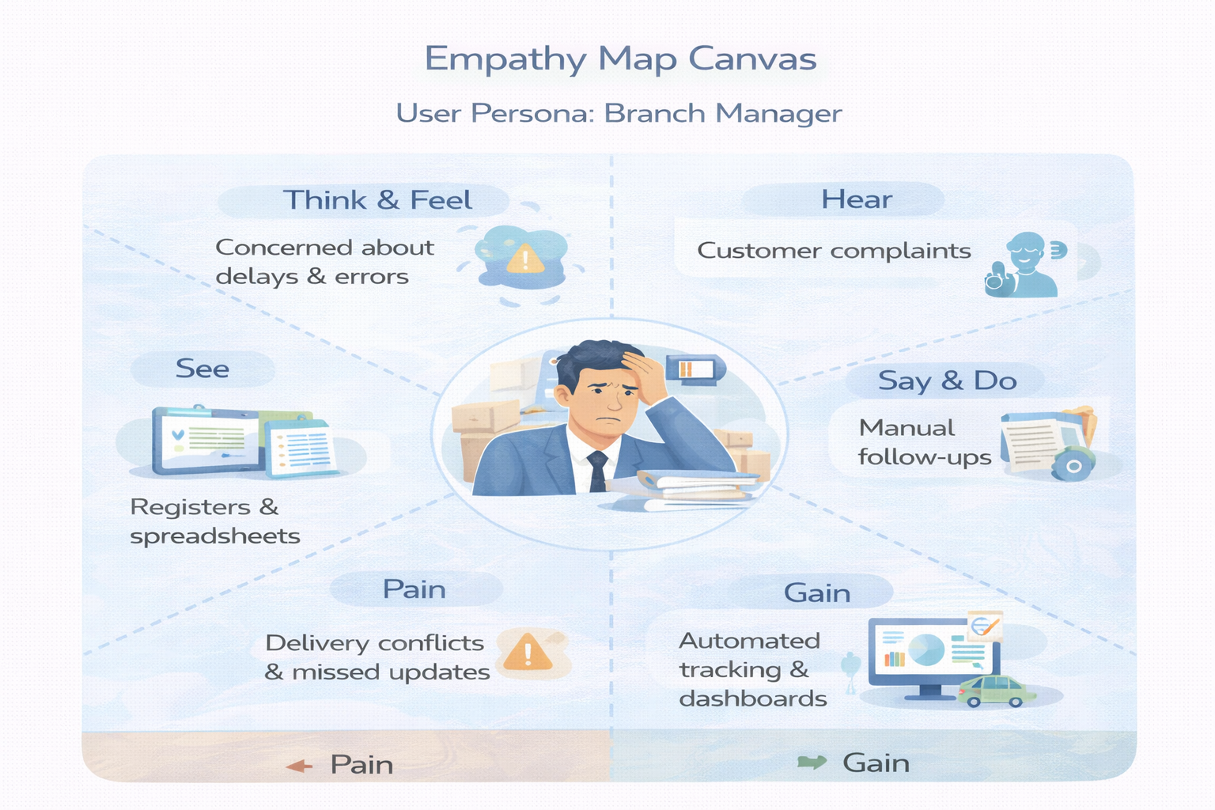

2.3 Brainstorming & Idea Prioritization
Ideas Considered

Manual registers

Spreadsheet tracking

Standalone portal

Salesforce CRM

Final Selection
Salesforce CRM selected due to:

Automation

Scalability

Real-time visibility

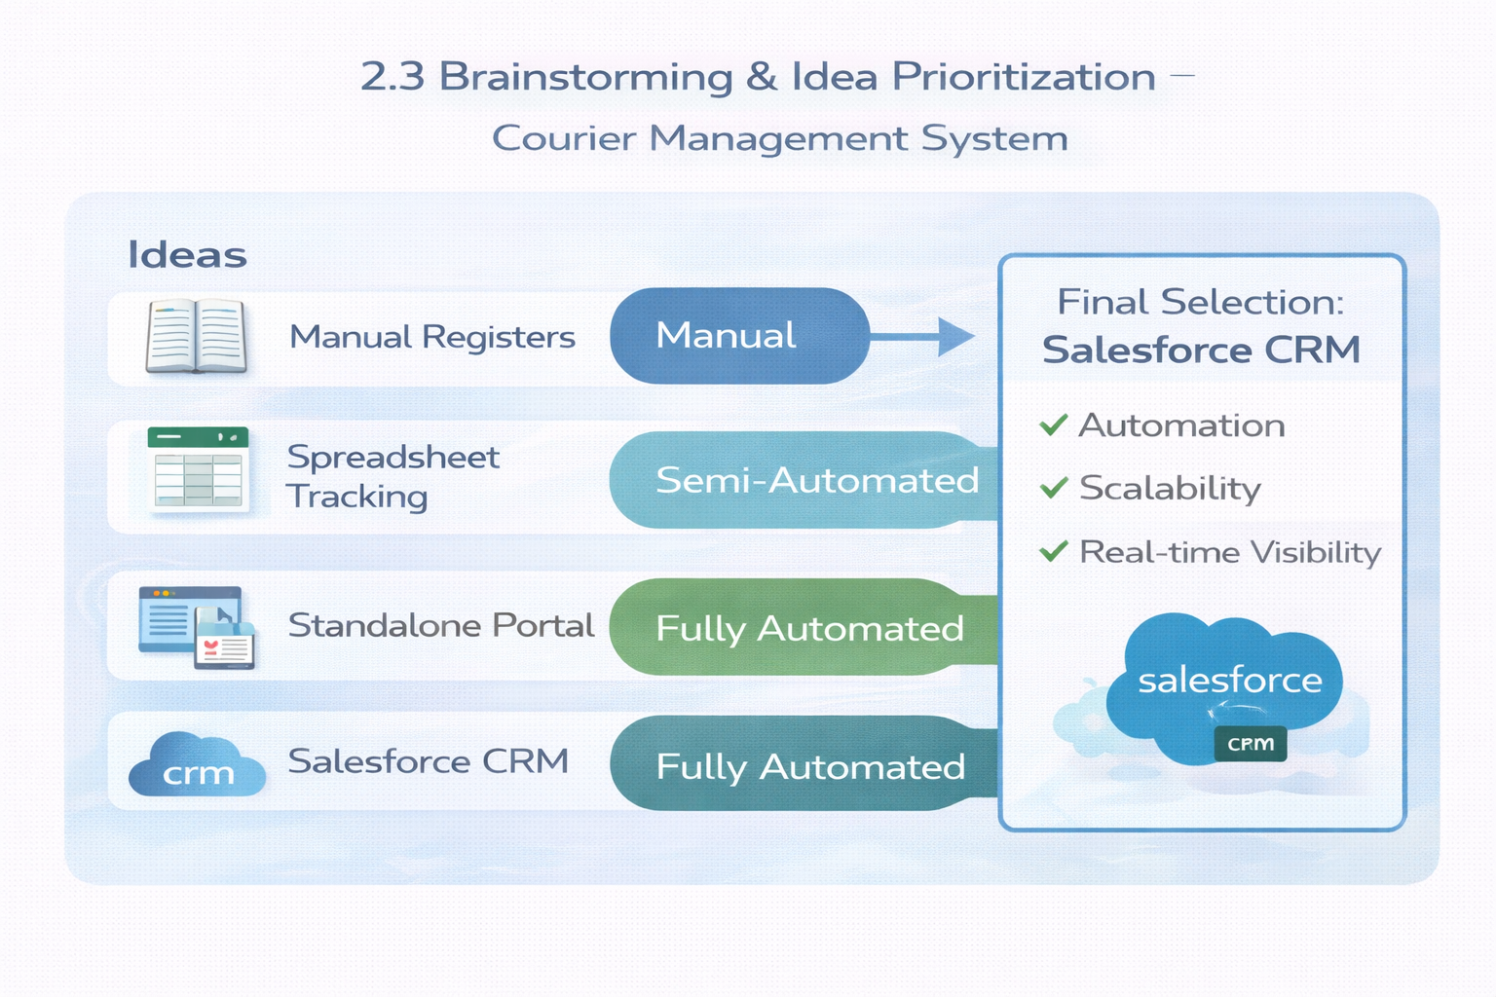

3.REQUIREMENT ANALYSIS PHASE

3.1 Customer Journey Map
Stages:

Booking → Shipment Creation → Agent Assignment → Transit → Delivery Update → Invoice → Reporting

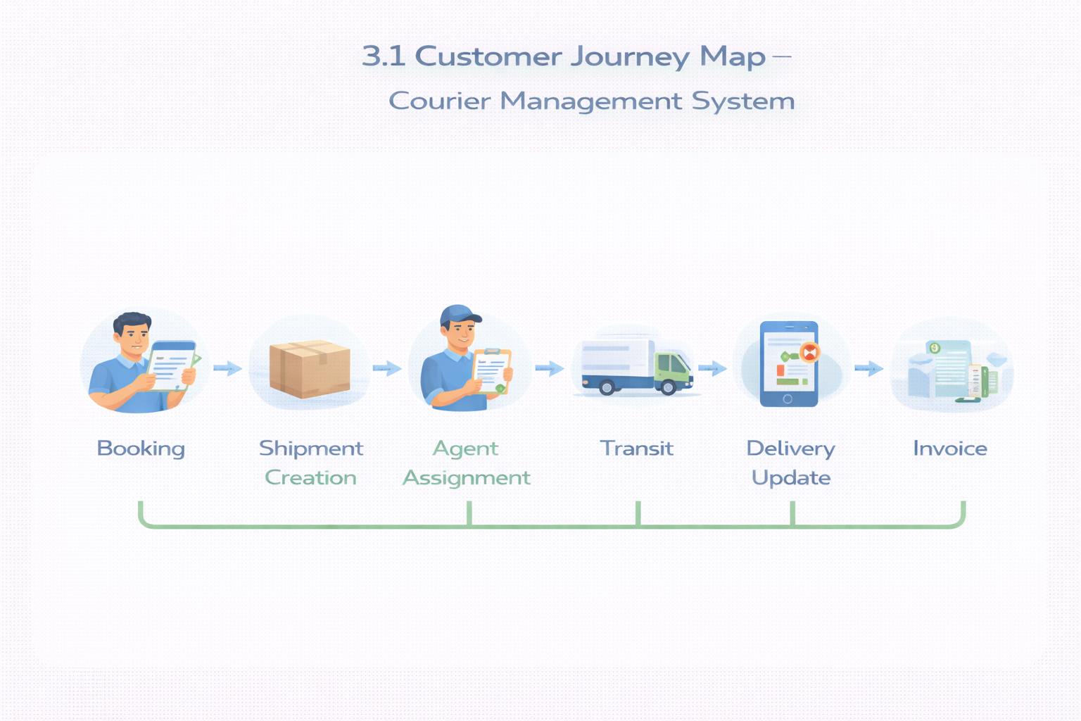

3.2 Solution Requirements
Functional Requirements

FR No | Requirement
FR-1 | Customer management
FR-2 | Shipment booking
FR-3 | Delivery agent assignment
FR-4 | Real-time status updates
FR-5 | Invoice generation
FR-6 | Reports & dashboards

Non-Functional Requirements

NFR | Description
Usability | Easy Lightning interface
Security | Role-based access control
Reliability | Error-free automation
Performance | Fast tracking updates
Availability | 24/7 cloud access
Scalability | Supports growing branches

3.3 Data Flow Diagram
Flow:
Customer Input → Shipment Creation → Validation → Agent Assignment → Delivery Update → Invoice → Reports
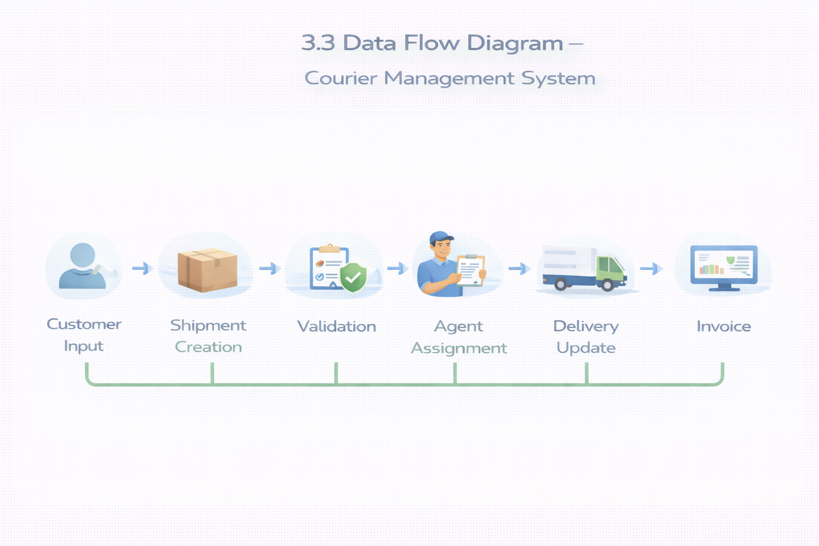

3.4 Technology Stack
Layer | Technology
UI | Salesforce Lightning
Logic | Salesforce Flows
Database | Salesforce Objects
Automation | Validation Rules, Flows
Security | Profiles, Roles
Reporting | Reports & Dashboards

4. PROJECT DESIGN PHASE

4.1 Problem–Solution Fit
CMS eliminates fragmented courier operations by automating shipment tracking, delivery assignment, billing, and reporting within a centralized Salesforce platform.
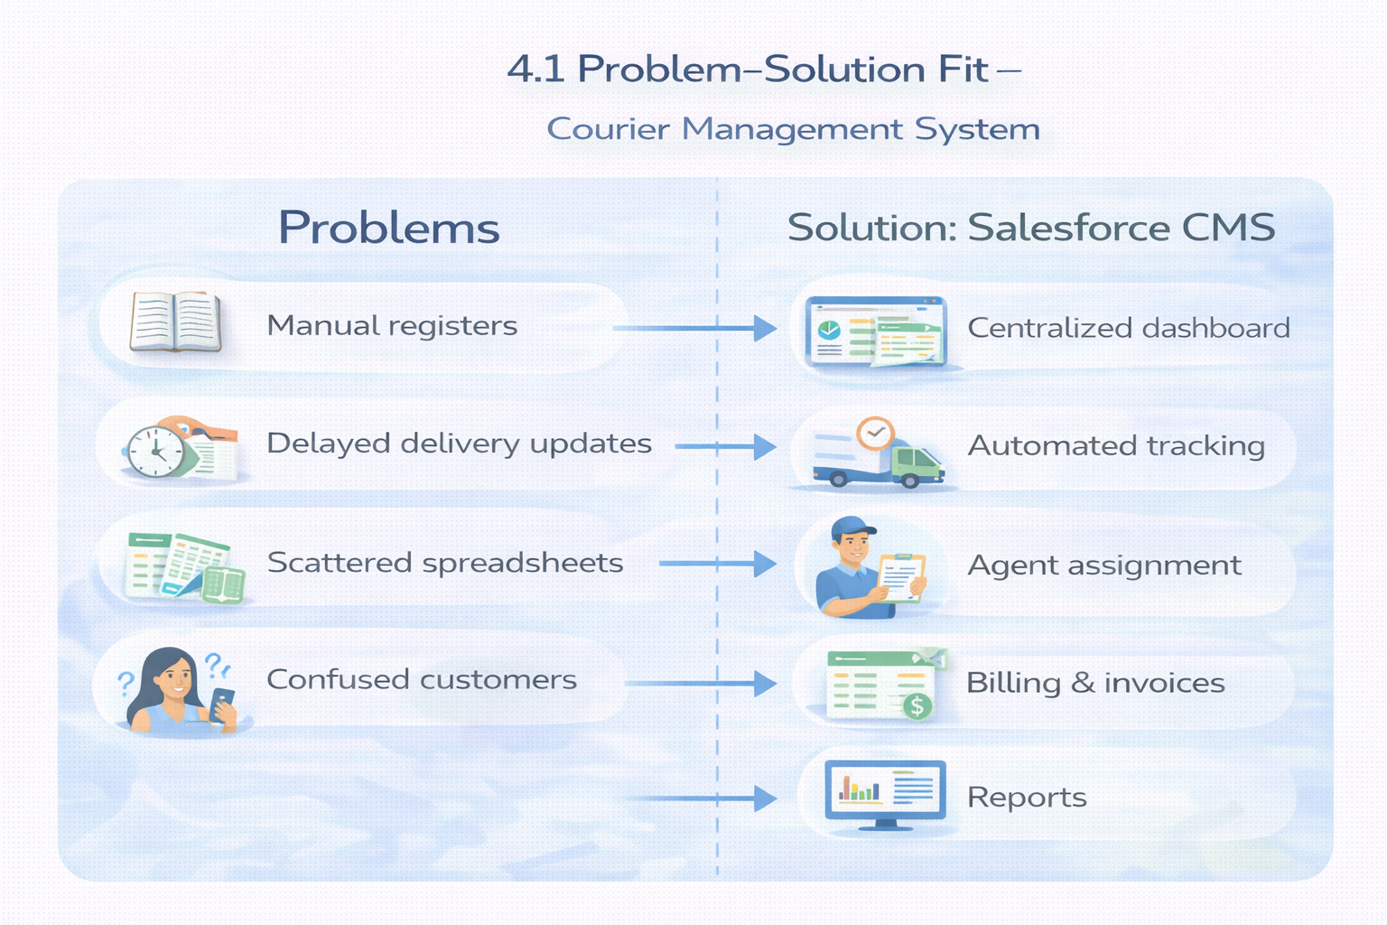

4.2 Proposed Solution
Functional Requirements

Parameter | Description
Problem | Manual shipment management
Solution | Salesforce CMS
Innovation | Automated tracking & billing
Impact | Faster deliveries
Business Model | Courier services
Scalability | Multi-branch ready

4.3 Solution Architecture
Components:

Customer Object

Shipment Object

Delivery Agent Object

Branch Object

Delivery Update Object

Invoice Object

Flows

Reports

Dashboards

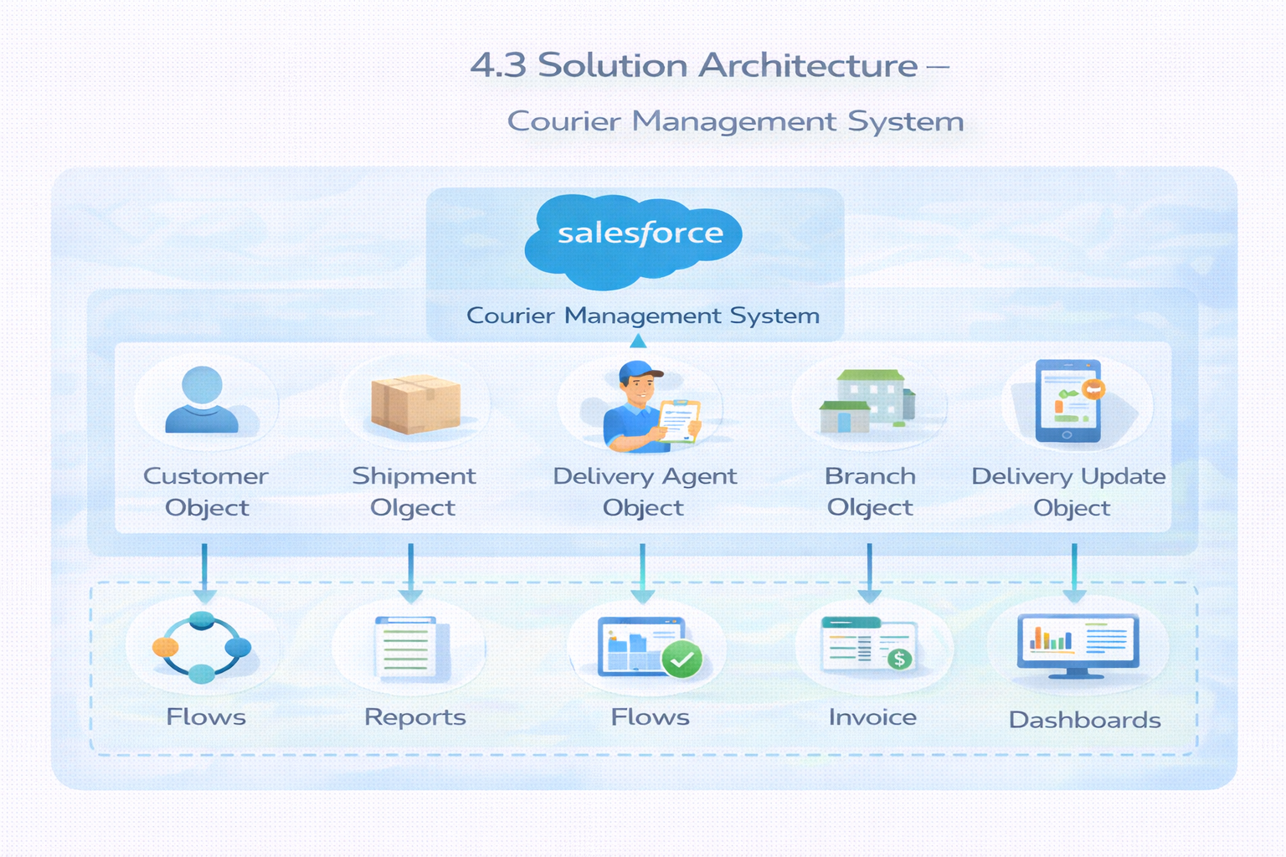

5. PROJECT PLANNING & SCHEDULING

5.1 Project Planning

Agile methodology

Epics → Stories → Story Points

Sprint-based execution

Velocity calculation used for estimation

Product Backlog, Sprint Schedule, and Estimation (4 Marks)
Use the below template to create product backlog and sprint schedule
Sprint | Functional Requirement (Epic) | User Story Number | User Story / Task | Story Points | Priority | Team Members
Sprint-1 | Developer Setup | USN-1 | As a system administrator, I want to create and configure a Salesforce developer account so that I can set up and deploy the Courier Management System. | 3 | High | Member1
Sprint-2 | Data Modeling | USN-2 | As an admin, I want to create Customer, Shipment, Delivery Agent, Branch, and Invoice objects with proper relationships so that courier data is stored and managed efficiently. | 5 | High | Member2
Sprint-2 | Data Modeling | USN-3 | As a staff member, I want tabs and a Lightning App for all courier modules so that I can easily navigate and perform daily operations. | 5 | High | Member3
Sprint-3 | Automation | USN-4 | As a system, I want to validate shipment details such as delivery dates, addresses, and mandatory fields so that incorrect or incomplete records are prevented. | 3 | High | Member4
Sprint-3 | Automation | USN-5 | As a dispatcher, I want automated flows for shipment status updates and agent assignment so that deliveries are processed faster without manual intervention. | 3 | High | Member4
Sprint-4 | Security | USN-6 | As an administrator, I want role-based access control for managers, agents, and staff so that sensitive shipment and billing data is secure. | 5 | High | Member2
Sprint-5 | Reports | USN-7 | As a branch manager, I want reports showing delivery performance, shipment status, and revenue so that I can monitor operations and make informed decisions. | 4 | High | Member3
Sprint-6 | Dashboards | USN-8 | As a branch manager, I want dashboards showing delivery performance, shipment status, and revenue so that I can monitor operations and make informed decisions. | 4 | Medium | Member4

Project Tracker, Velocity & Burndown Chart: (4 Marks)
Sprint | Total Story Points | Duration | Sprint Start Date | Sprint End Date (Planned) | Story Points Completed (as on Planned End Date) | Sprint Release Date (Actual)
Sprint-1 | 20 | 6 Days | 24 Oct 2022 | 29 Oct 2022 | 20 | 29 Oct 2022
Sprint-2 | 20 | 6 Days | 31 Oct 2022 | 05 Nov 2022
Sprint-3 | 20 | 6 Days | 07 Nov 2022 | 12 Nov 2022
Sprint-4 | 20 | 6 Days | 14 Nov 2022 | 19 Nov 2022

